**MINI PROJECT**

**(2020-2021)**

**Stock Market Price Prediction App: “Stock Money”**

**MID-TERM REPORT**



**Institute of Engineering & Technology**

**Submitted by**

**Abhijeet Nag: abhijeet-nag**

**Shashwat Pandey: shashwattpandeyy**

**Avi Vivek: avi-vivek**

**Vaibhav Srivastava: vaibhav200-cloud**

**INDEX**

1. **Abstract**
2. **Introduction**
   1. Definition
   2. Description
3. **Problem definition**
4. **Objectives**
5. **Some Screenshots**
6. **References**

**Abstract**

This report lays out a project plan for the development of the “Stock Money” open source repository system.

The intended readers of this document are current developers working on “Stock Money”. The plan will include but is not restricted to, a summary of the system functionality, the scope of the project from the perspective of the “Stock Money” team (Our team and my mentors), the process by which we will develop the project, and metrics and measurements that will be recorded throughout the project.

**Introduction**

**Definition:** A stock market is a place where shares of public listed companies are traded. The primary market is where companies float shares to the general public in an initial public offering (IPO) to raise capital.  
  
**Description:**Once new securities have been sold in the primary market, they are traded in the secondary market—where one investor buys shares from another investor at the prevailing market price or whatever price both the buyer and seller agree upon. The secondary market or the stock exchanges are regulated by the regulatory authority. In India, the secondary and primary markets are governed by the Security and Exchange Board of India (SEBI).

A stock exchange facilitates stock brokers to trade company stocks and other securities. A stock may be bought or sold only if it is listed on an exchange. Thus, it is the meeting place of the stock buyers and sellers. India's premier stock exchanges are the Bombay Stock Exchange and the National Stock Exchange.

There are some little bit similar applications available:

**1.Stock market predictor: -**

This application tries to determine the future price of company stock. The successful prediction of the stock future price leads to significant profit. It works with the past values of the company and gives the approximate range for the stock price.

**FEATURES: -**

1. It gives an approximate range of stock prices.
2. Users can get significant profits easily.

**2.Stock Market: NSE Price Prediction:**

NSE price prediction is simple and easy to use in stock market applications. Users can easily track stock prices, create a portfolio, and search stocks by symbols. Users can easily get predicted closing prices before 3 hours later. The application's interface is very simple and the user can easily access all the features.

**FEATURES: -**

1. Simple and easy interface.
2. Easy to create a portfolio.
3. Easy to search.

**3**. **Grow Application**:

This application is simplest Demand and stock trading application that allows you to open Demat account & trade BSE, NSE stocks in the share market at Rs. 0 brokerage on investments.

**FEATURES:**

1. Very simple and easy application.
2. You can invest in readymade collection of mutual funds which is recommended by top experts.
3. It shows complete information about all companies that let you make informed decisions.
4. A high level of encryption standards is used for all transactions which make Grow application safer as compared to bank.

**App design & develop:**

Having you're App designed and built professionally will improve your company image and help to enforce your brand.

**About the Project**

**A) WHAT DO WE WANT TO CREATE?**

A stock market prediction android application.

**B) WHAT IS OUR IDEA ABOUT?**

It is an android based application that predicts the stock market by analyzing the company's statistics and the shares bought by it, by using Machine Learning.

**1) WHO?**

**1.1) Who does our application target?**

Our application targets the budding stock market enthusiasts as well as the investors. Whether they know about the market or not people can easily see the predictions made by the app and use the knowledge accordingly.

**2) WHAT?**

**2.1) What is the boundary of the problem?**

Every investor weather the day traders or the long-term traders, they both have this common problem of not being able to predict the stocks correctly.

**2.2) What is the issue?**

The issue is that according to popular estimates, nearly 90% of people lose their money in stock markets, and this includes both the new and seasoned investors.

Before investing in shares of a company the investors always study and do thorough research on the company. Even after researching by themselves, they are not sure that they will earn or lose their money.

**2.3) What is the impact of the issue?**

There's a constant fear in the mind of the investor that he might lose his money altogether.

**2.4) What impact is this issue causing?**

Due to constant fear of losing the money altogether, the investors are avoiding investing their money on the companies which directly affect the GDP of a country. A fall in the share price of a company negatively impacts the economic growth of a county.

**2.5) What will happen if this problem is fixed?**

As soon as the problem is fixed the people will start earning with a much lower chance of risk.

**2.6) What would happen if we don't solve the problem?**

The present digital scenario has brought up so many new Companies/ Startups which are increasing day by day, and if the number of investors will decrease the company will not be able to support itself, thus downgrading our GDP.

**3) WHEN?**

**3.1) When did the issue start to occur?**

This issue started during the stock market establishment.

**3.2) When does it need to be fixed?**

It needs to be fixed right now! As many companies are establishing day by day and month by month and in the future, they need stocks/money to scale up their business, and without money, it is very difficult to scale up.

**4) WHERE?**

**4.1) Where does this issue occur?**

This issue occurs in every county where the stock market is prevalent.

**5) WHY?**

**5.1) Why is it important that we fix the problem?**

It is important because most people cannot predict the market as accurately as our program does.

**5.2) What impact does it have on the business or customer?**

The application will have a drastic impact on companies/businesses as well as investors. Businesses will be getting money to raise their capital as the investor count will increase and the investors who are our regular users will increase their profit ratio and their losses will be reduced. So, it's a win-win situation here.

**6) Our Solution**

Our Solution is to make an android based application that will predict the value of a company's stock soon with an accuracy of approximately 70%. So that users may take the correct decision of when to buy a stock or when to sell it to attain maximum profit.

**Android Technical Support**

**Technologies Languages :** XML,KOTLIN,FIREBASE

**Android app development platform:** Android Studio, Virtual device

**Server platform:** Windows

**Introduction to the Development tool “Android Studio”**

Android Studio is the official integrated development environment (IDE) for Android platform development. Android Studio is freely available under the apache license. Android Studio is designed specifically for Android development. Android application development can be started on either of the following operating systems – Microsoft® Windows® 8/7/Vista/2003 (32 or 64-bit). Mac® OS X® 10.8.5 or higher, up to 10.9 (Mavericks). GNOME or KDE desktop. All the required tools to develop Android applications are open source and can be downloaded from the Web. Following is the list of software's that is needed before starting Android application programming. Java JDK5 or later version Java Runtime Environment (JRE) 6 Android Studio.

**Stock Market Price Prediction App: “Stock Money”**

**Front page:**

**1) MainActivity.kt**

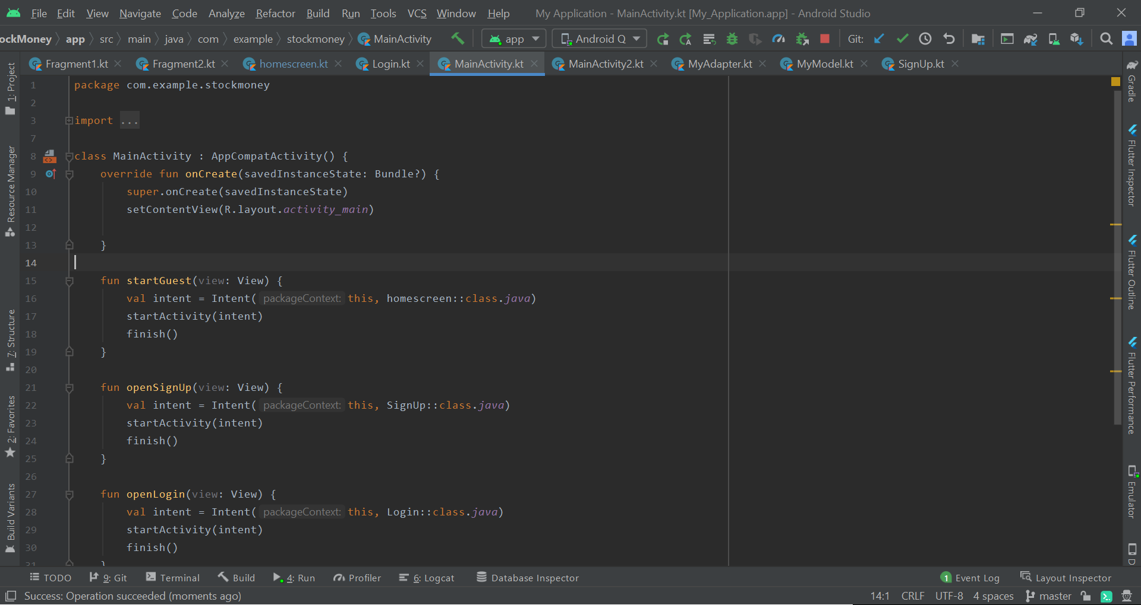

* 1. **Activity_main.xml**

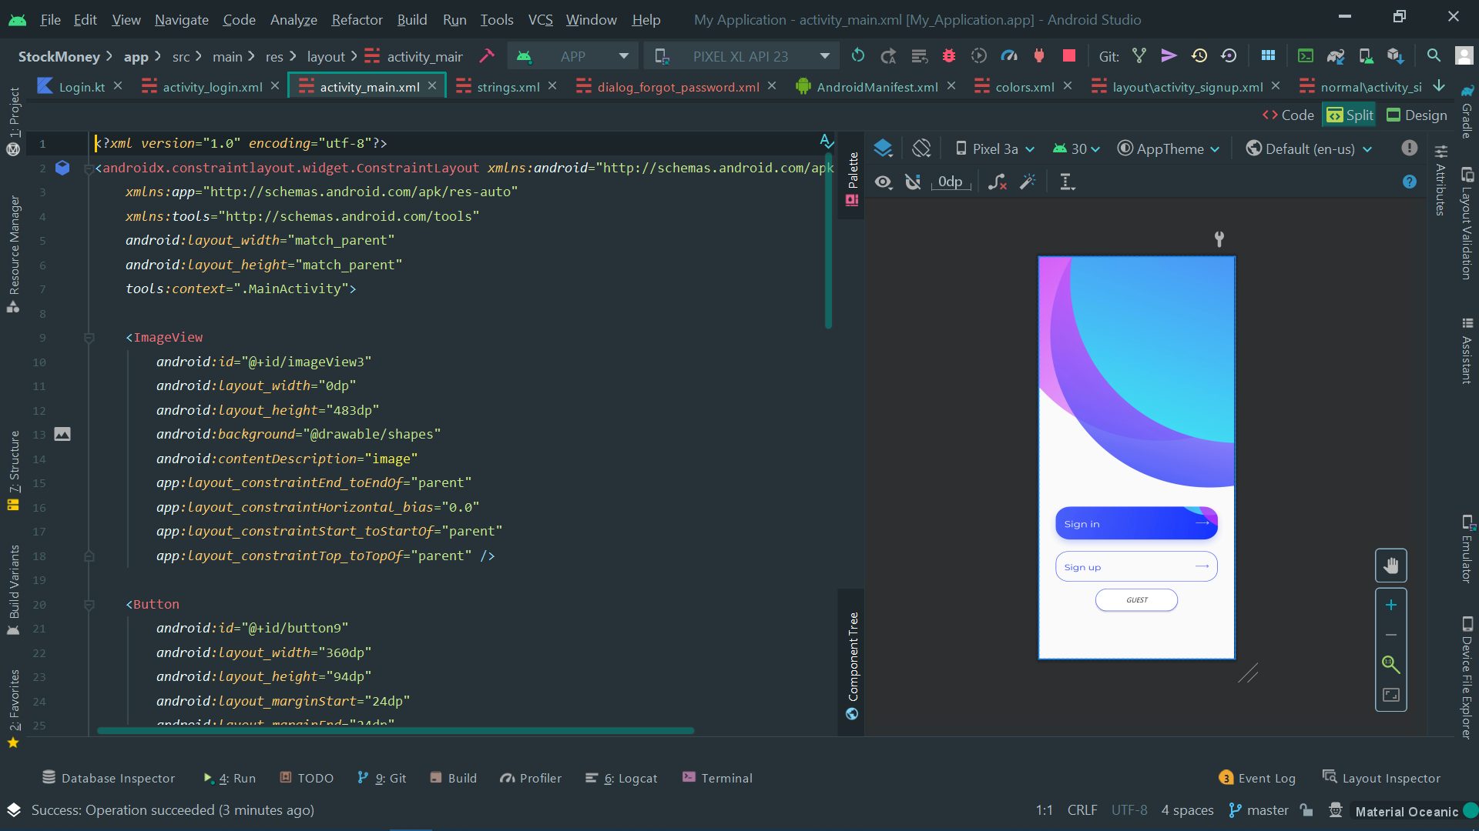

**2) Login code:**

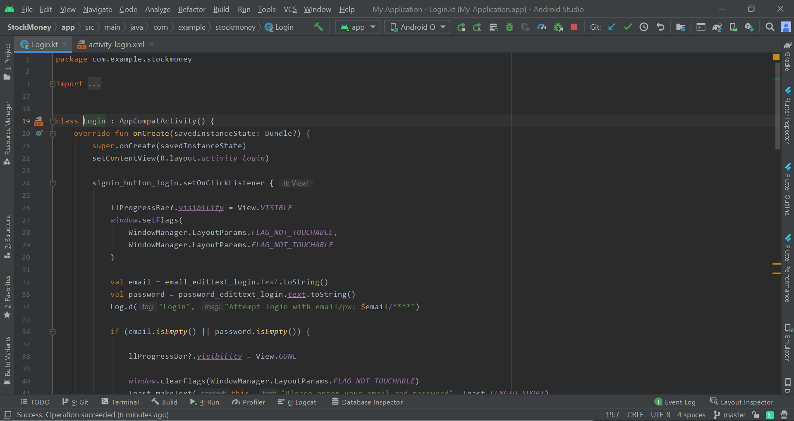

**2.1) Login XML:**

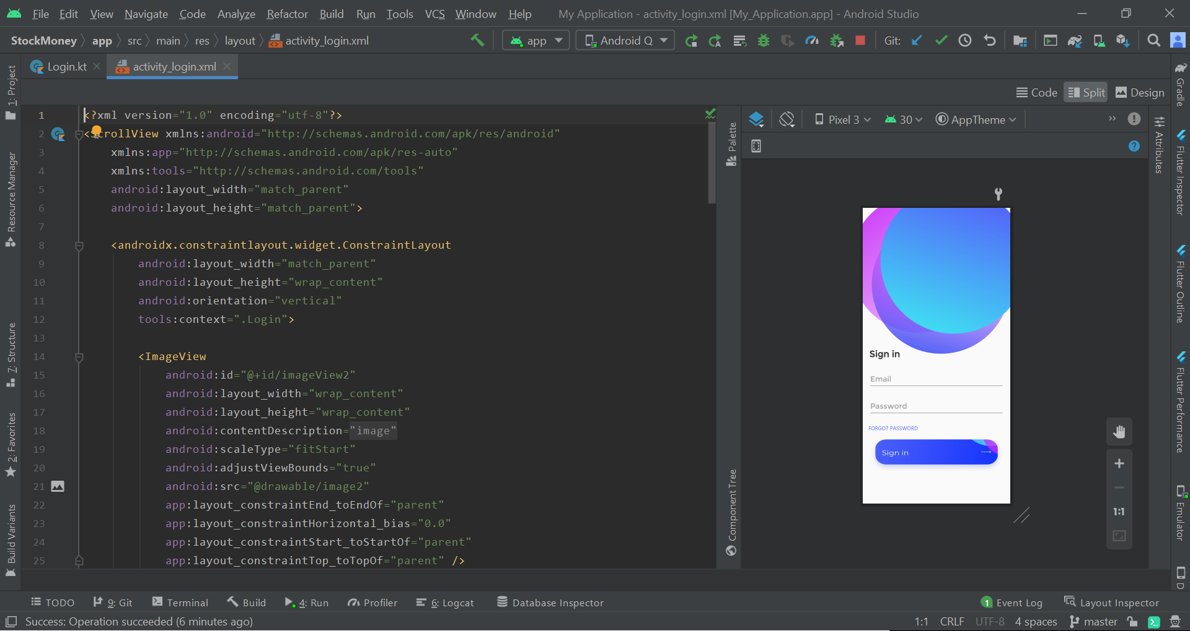

**3) SIGNUP KOTLIN CODE:**

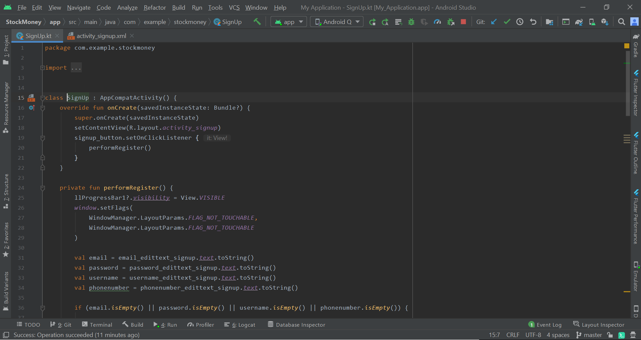

**3.1) SIGNUP XML CODE:**

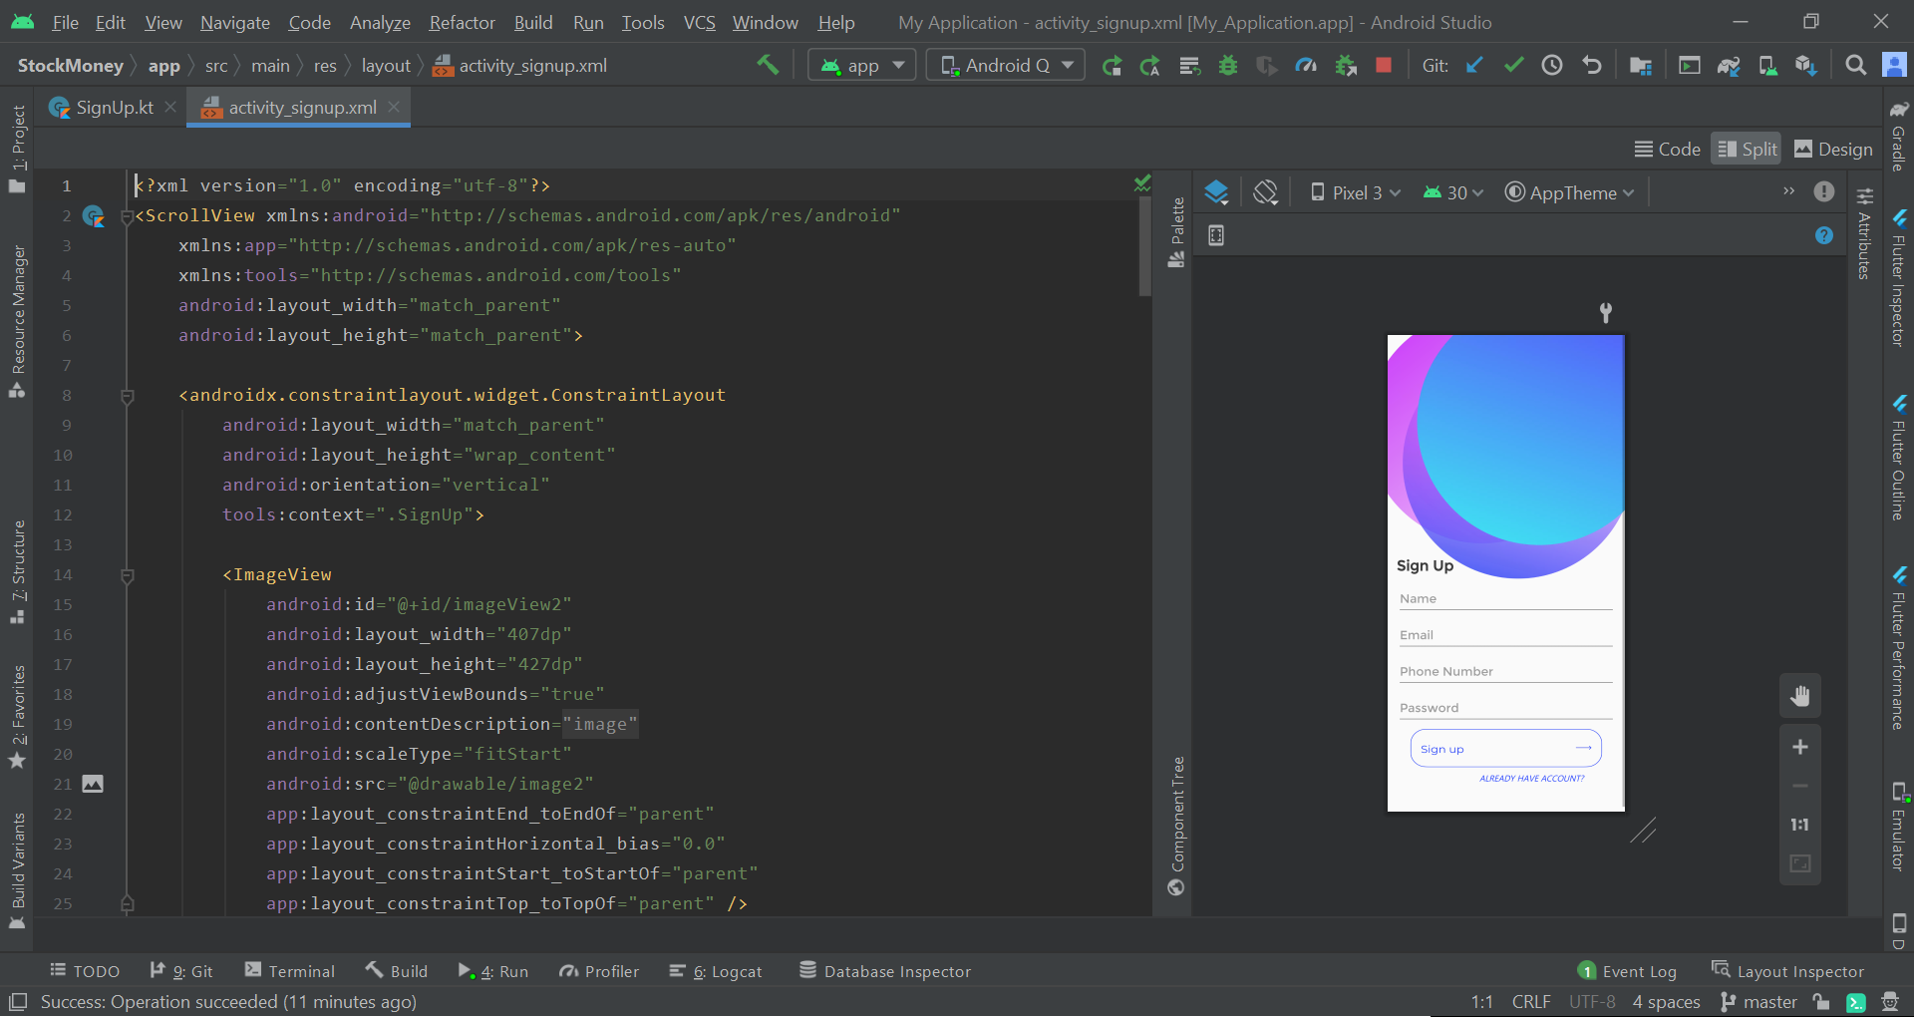

**4) HOMESCREEN KOTLIN CODE:**

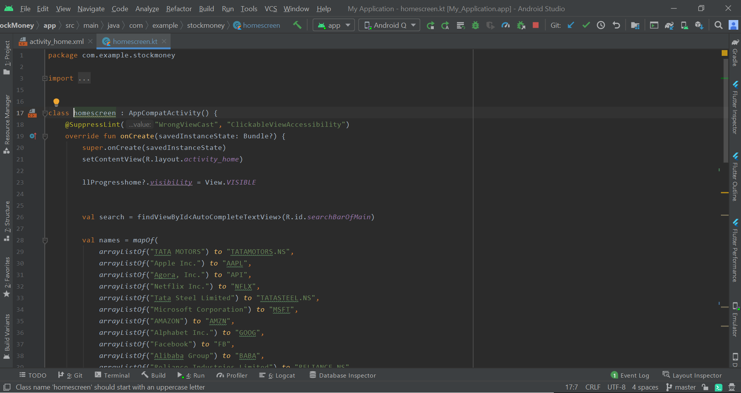

**4.1) HOME SCREEN XML CODE:**

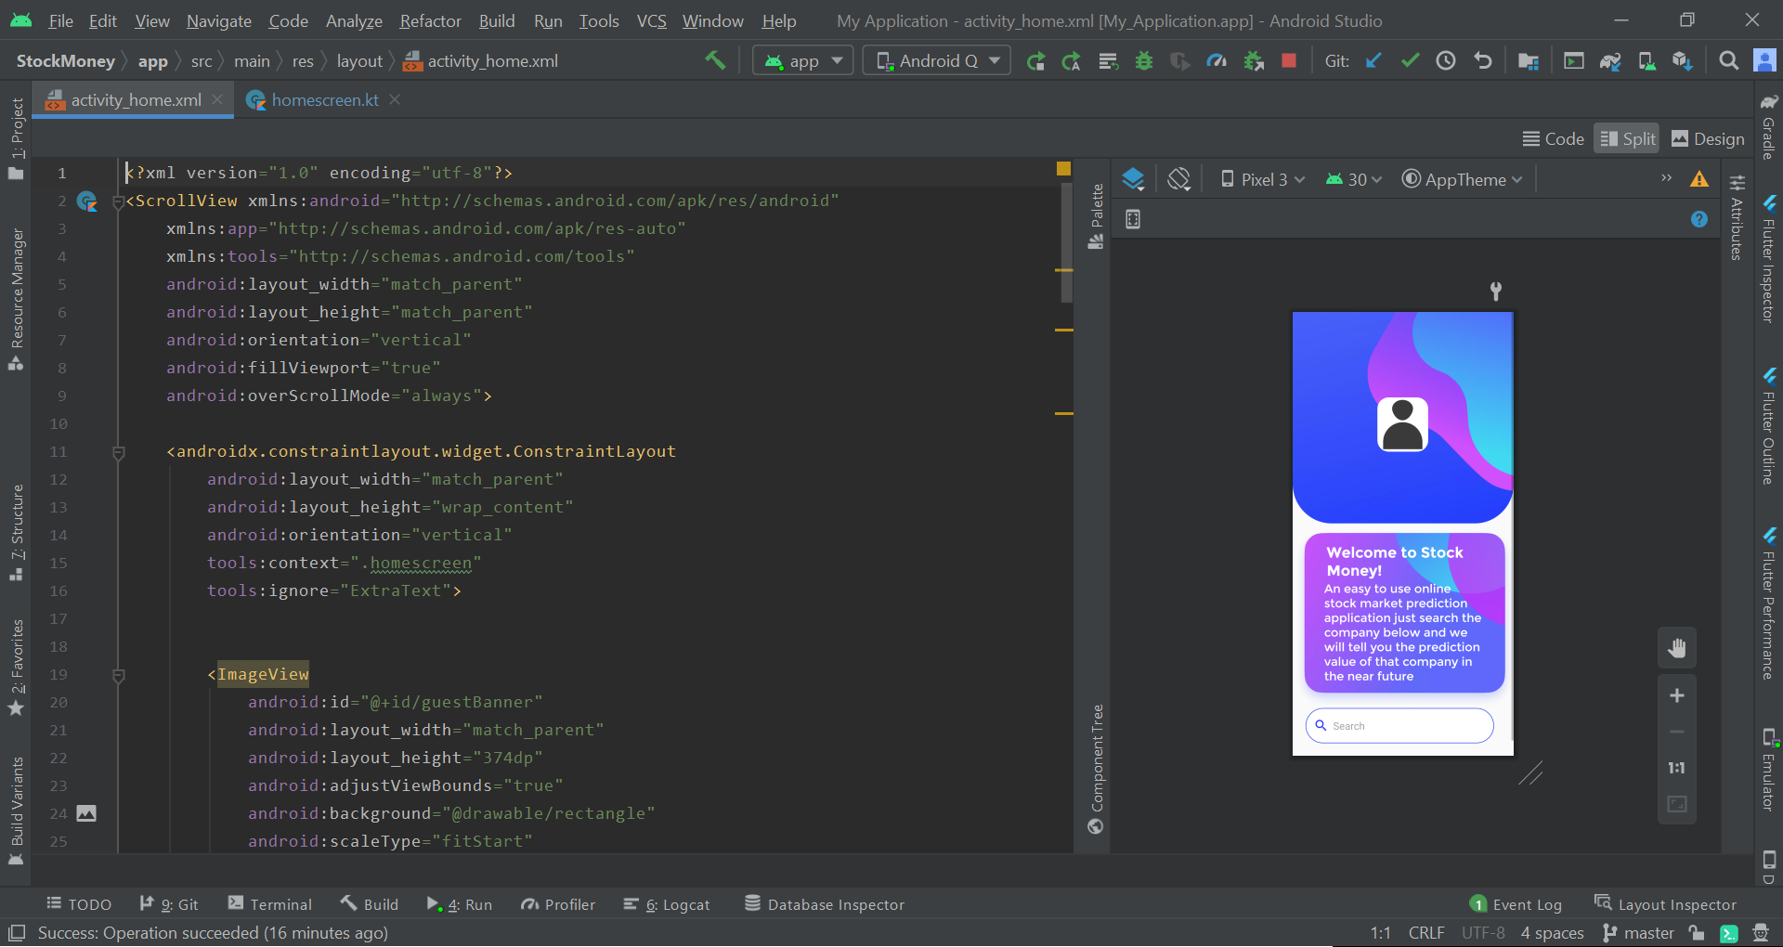

**5) MAIN ACTIVITY 2 KOTLIN CODE:**

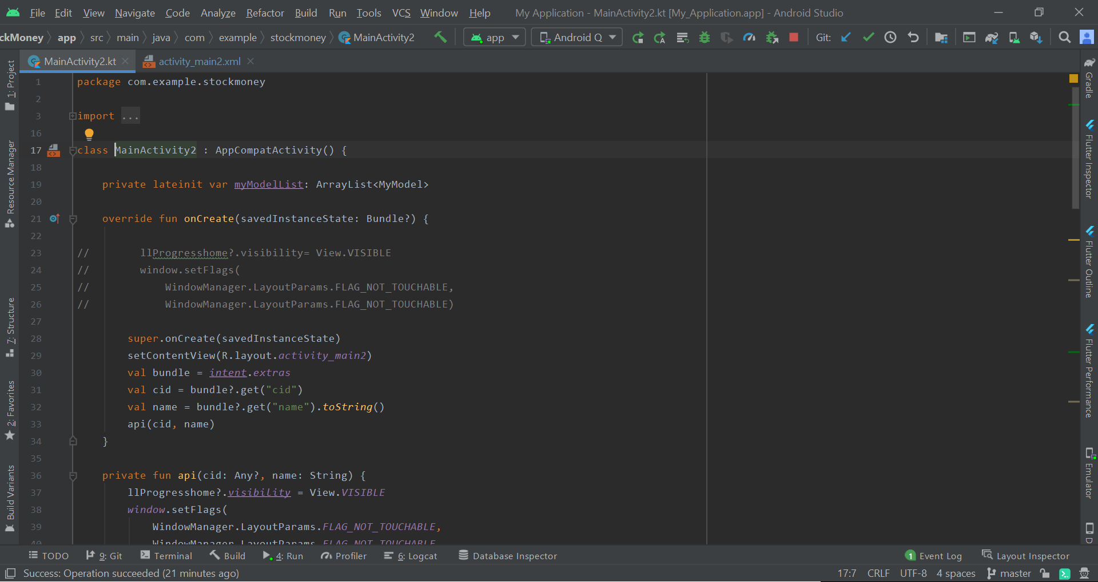

**5.1) MAIN ACTIVITY 2 XML CODE:**

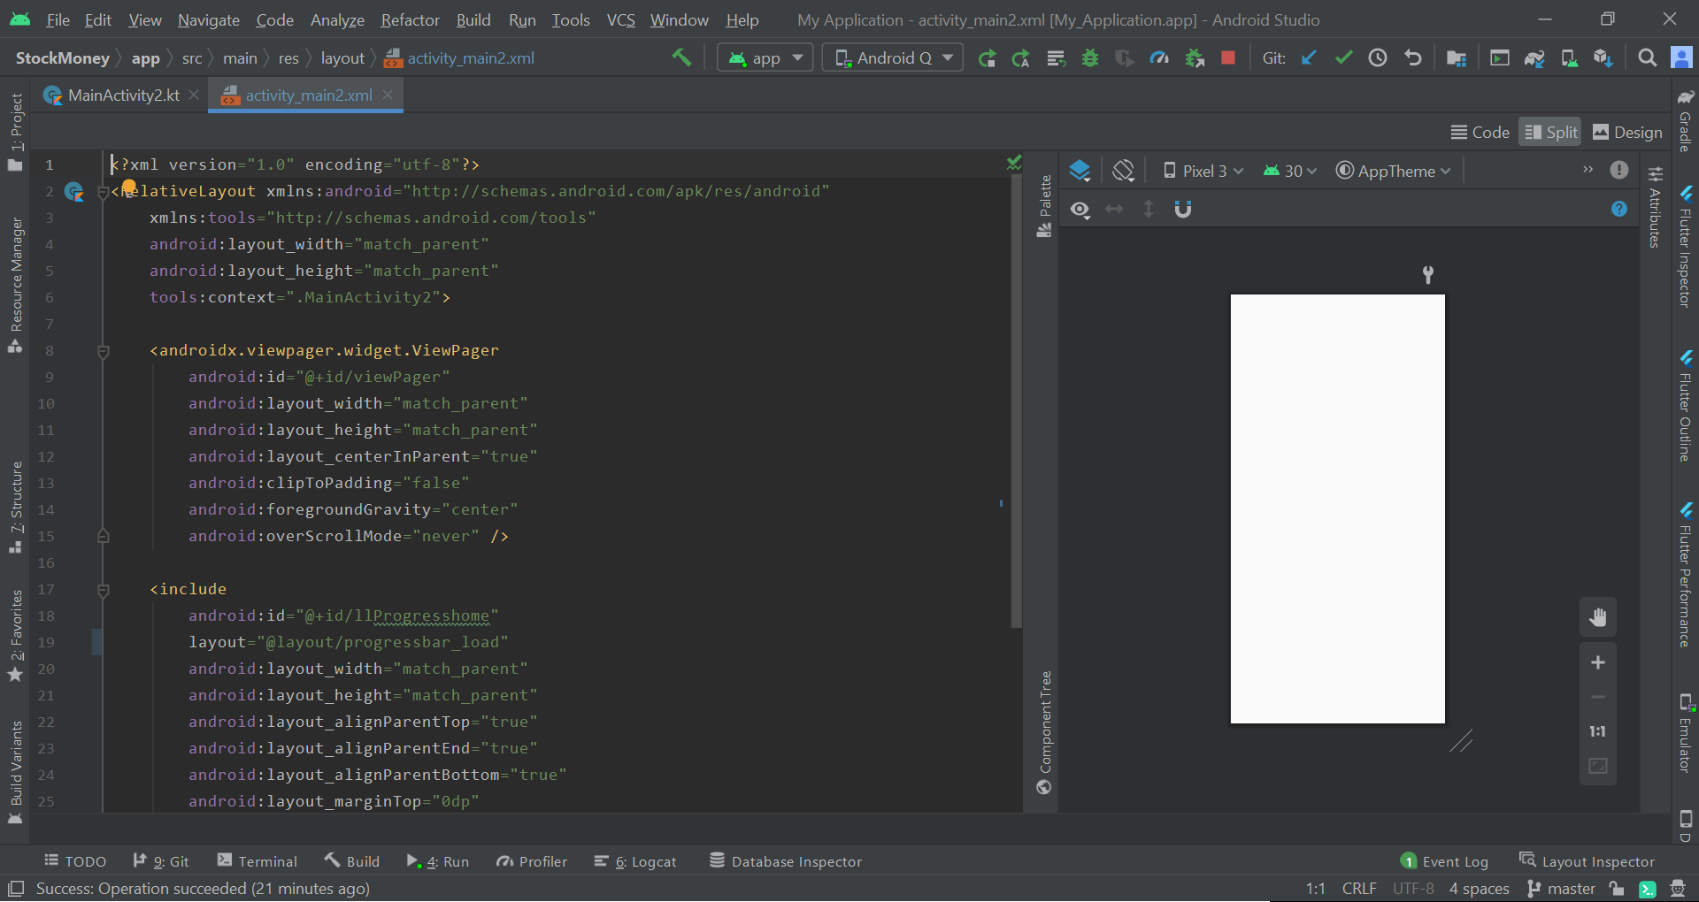

**6) MY ADAPTER KOTLIN CODE:**

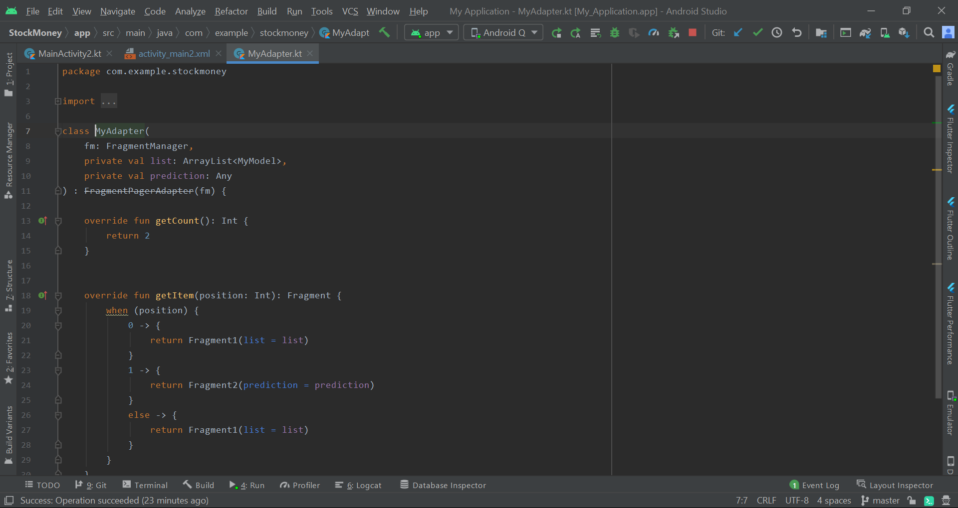

**7) MY MODEL KOTLIN CODE:**

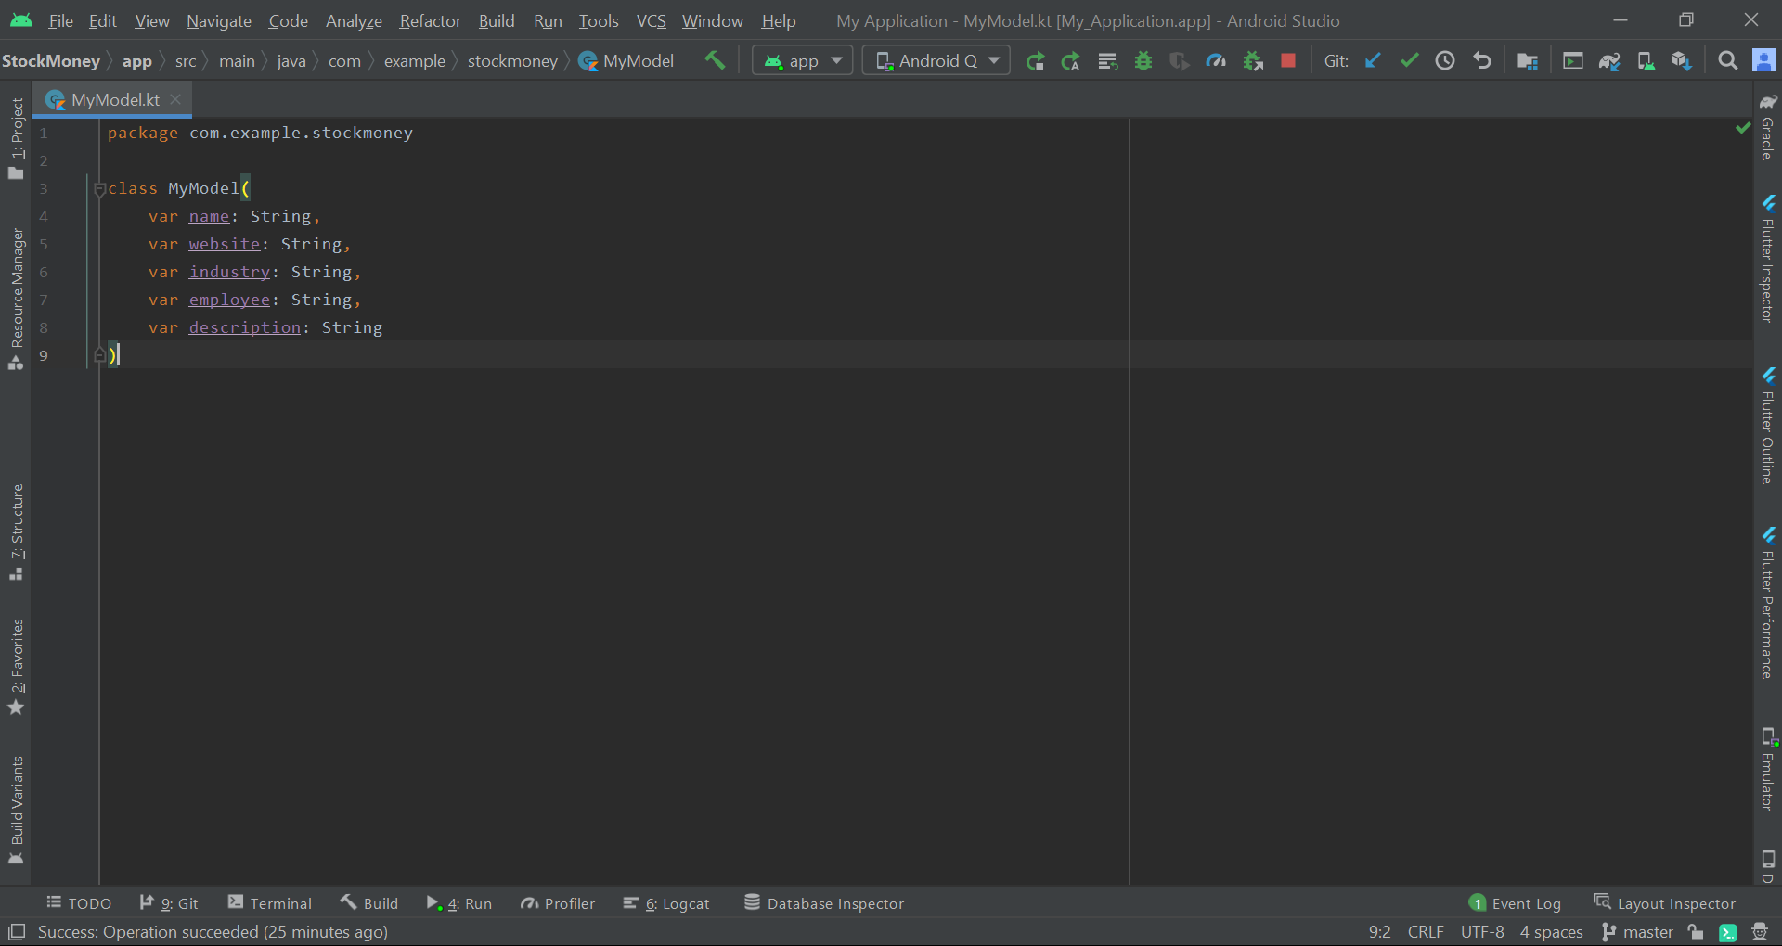

**8) FRAGMENT 1 KOTLIN CODE:**

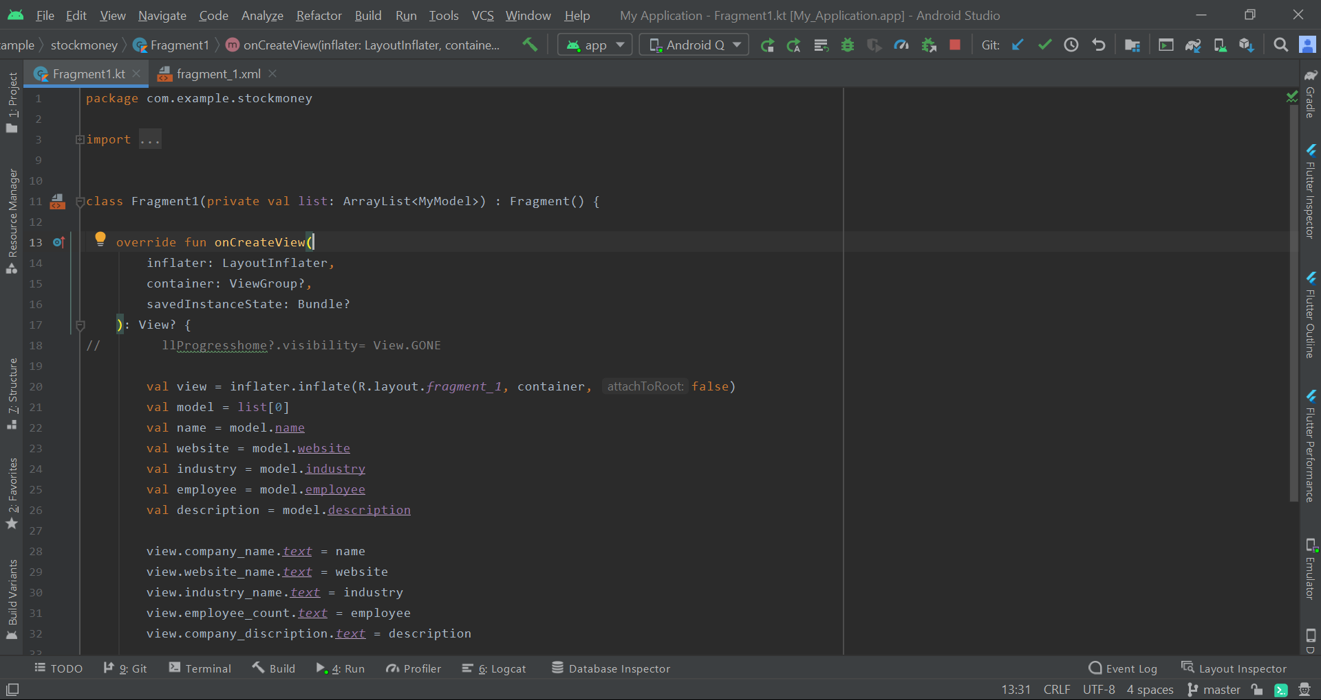

**8.1) FRAGMENT 1 XML CODE:**

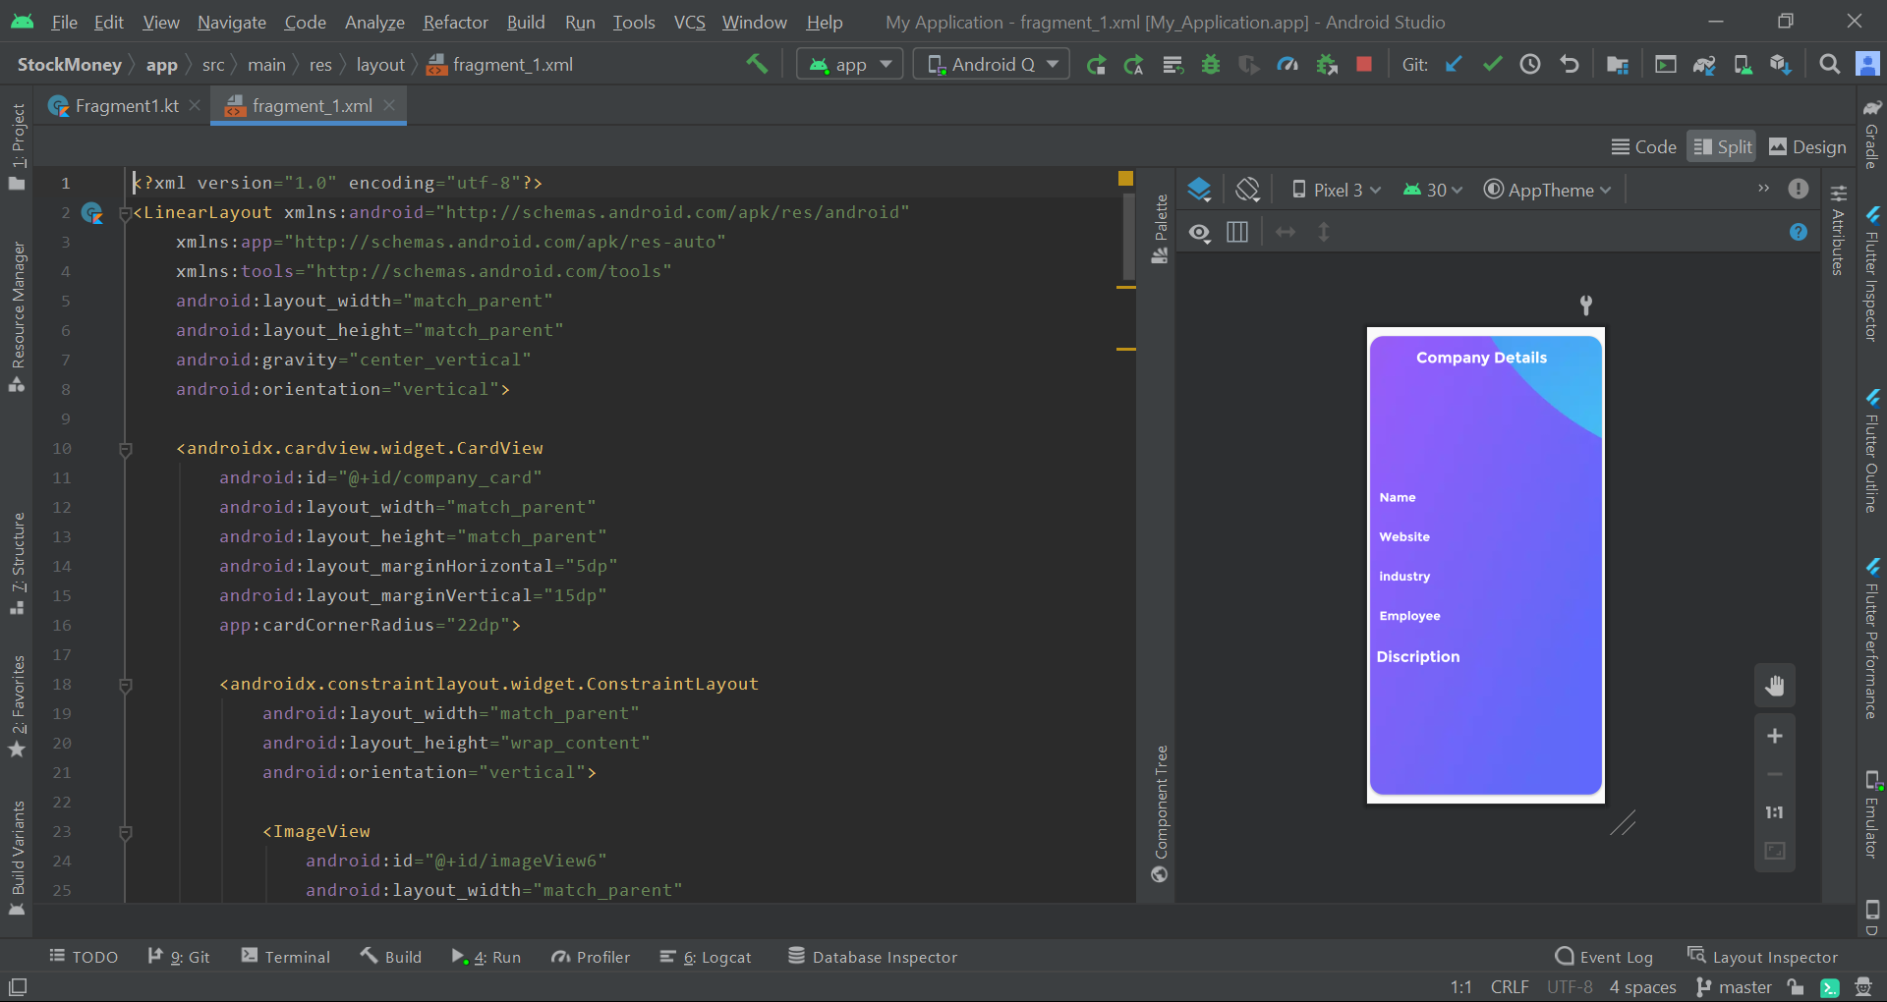

**9) FRAGMENT 2 KOTLIN CODE:**

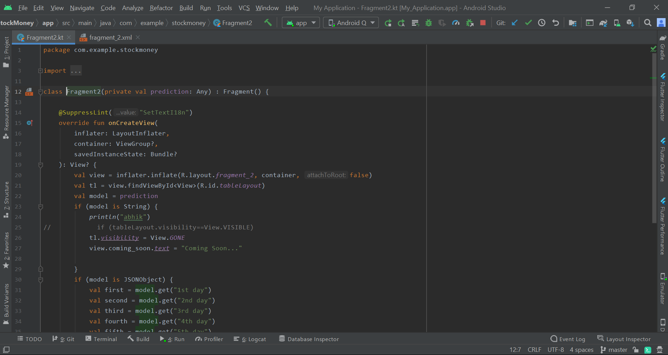

**9.1) FRAGMENT 2 XML CODE:**

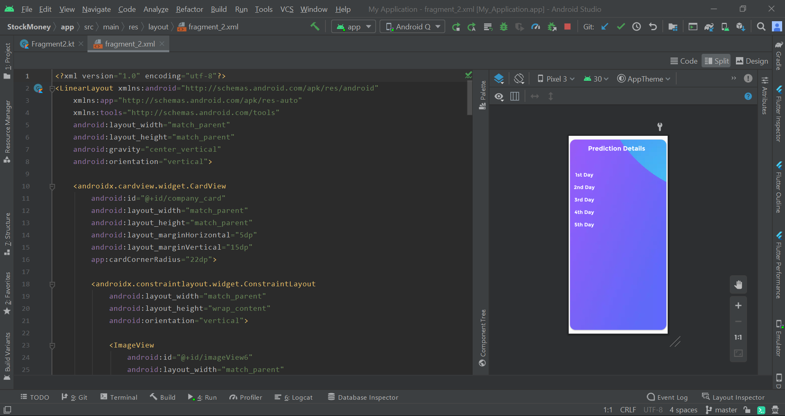

**10) FORGOT PASSWORD FIALOG XML CODE:**

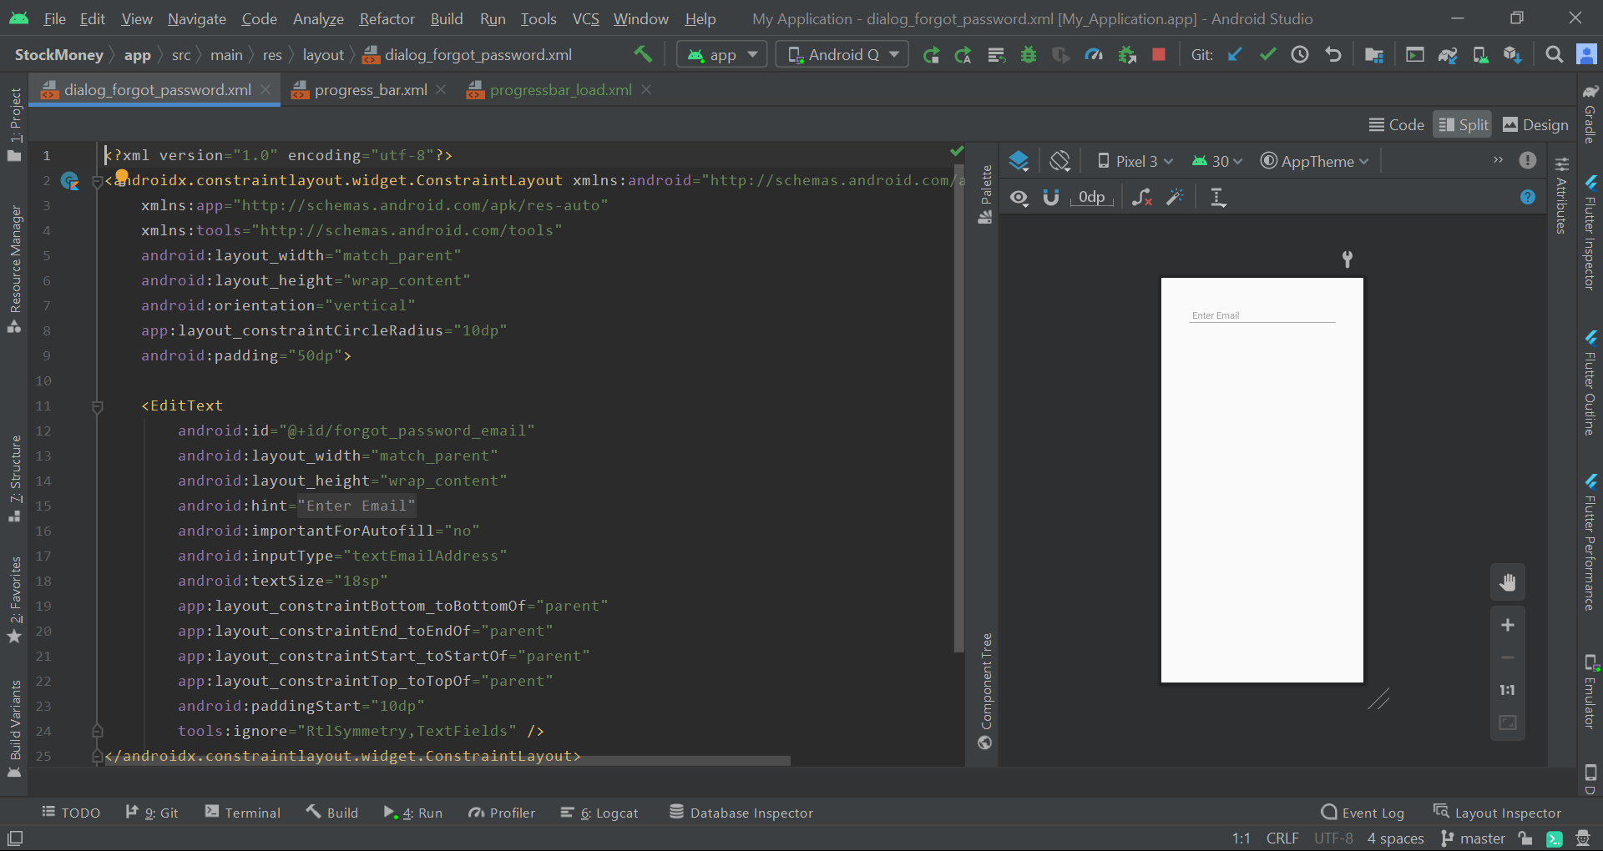

**11) PROGRESS BAR XML FILE:**

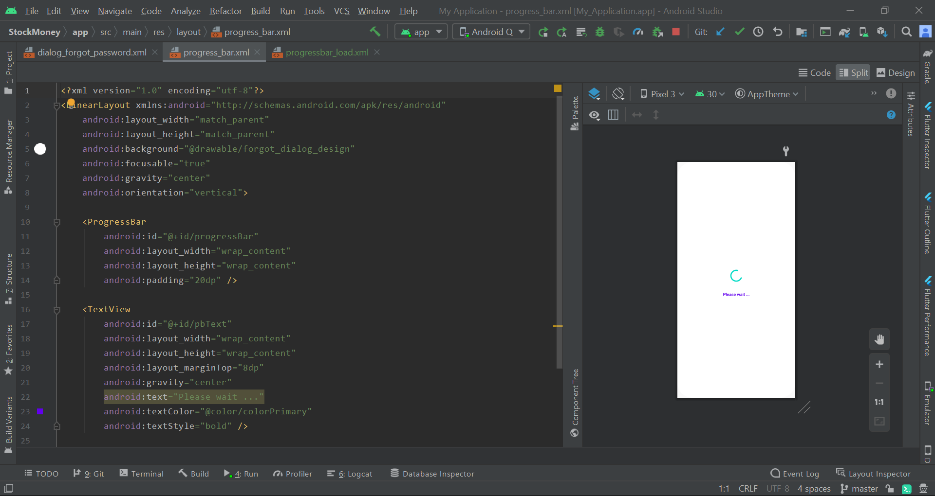

**12) PROGRESS BAR WITH ICON XML FILE:**

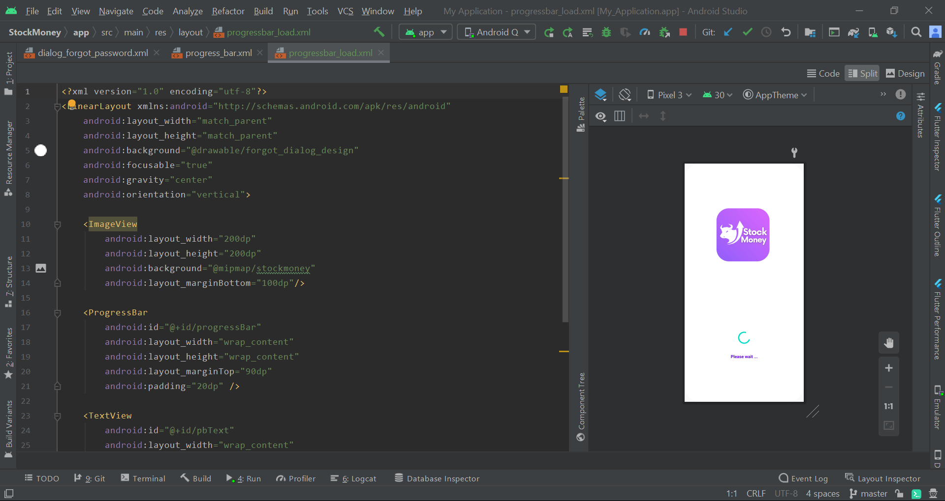

**STOCK MONEY UI:**

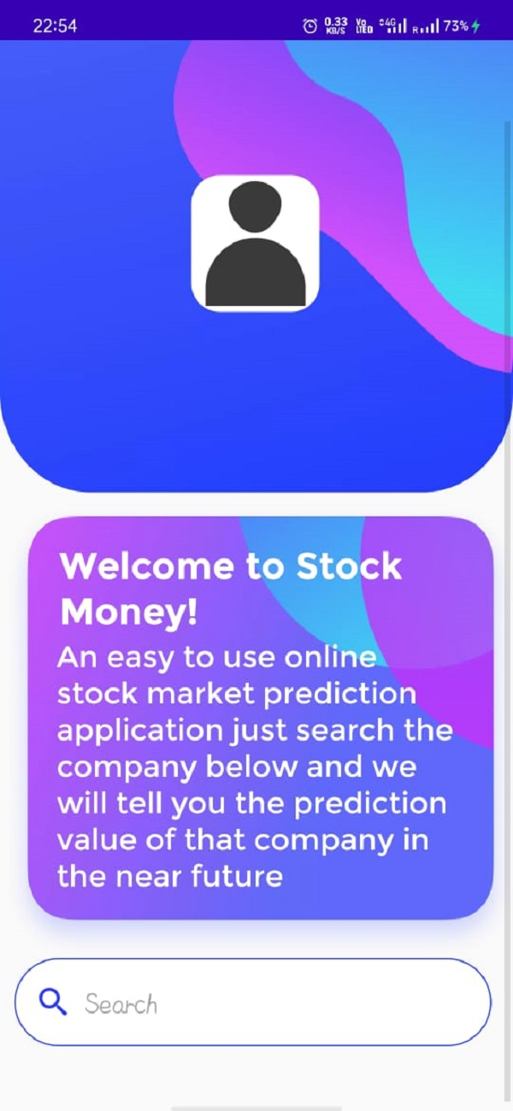

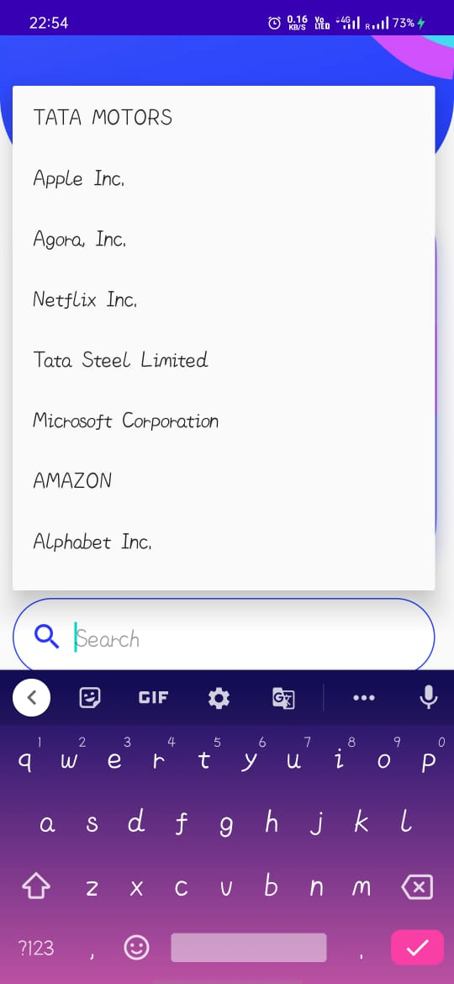 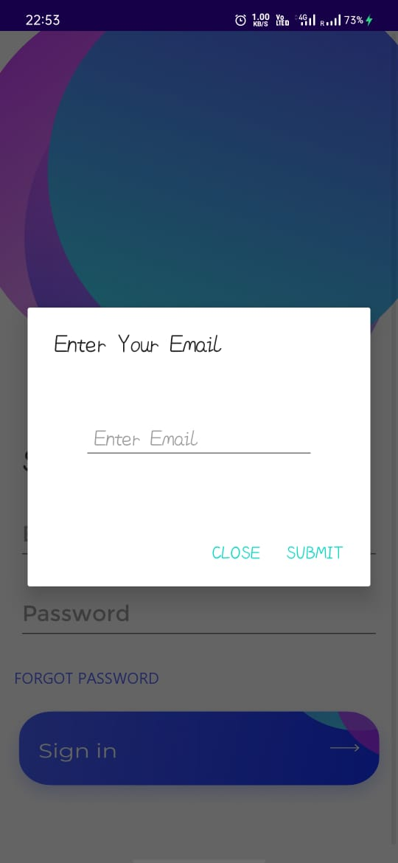

** **

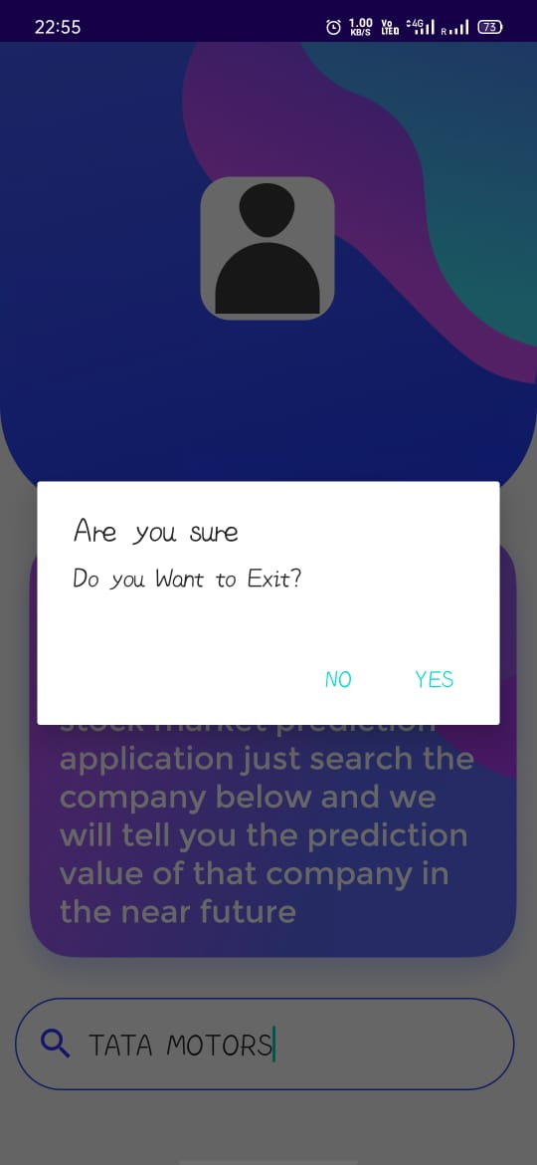 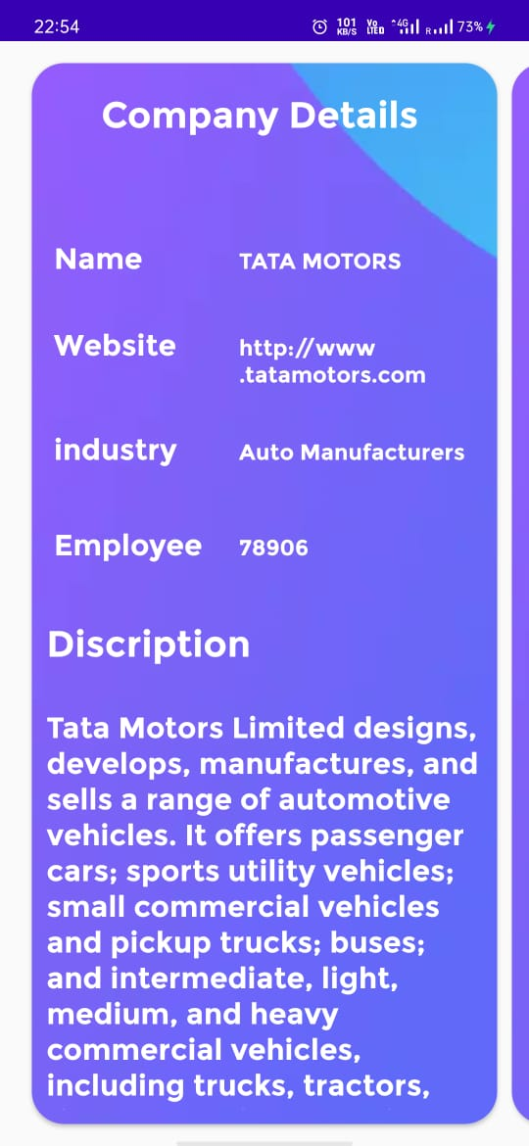

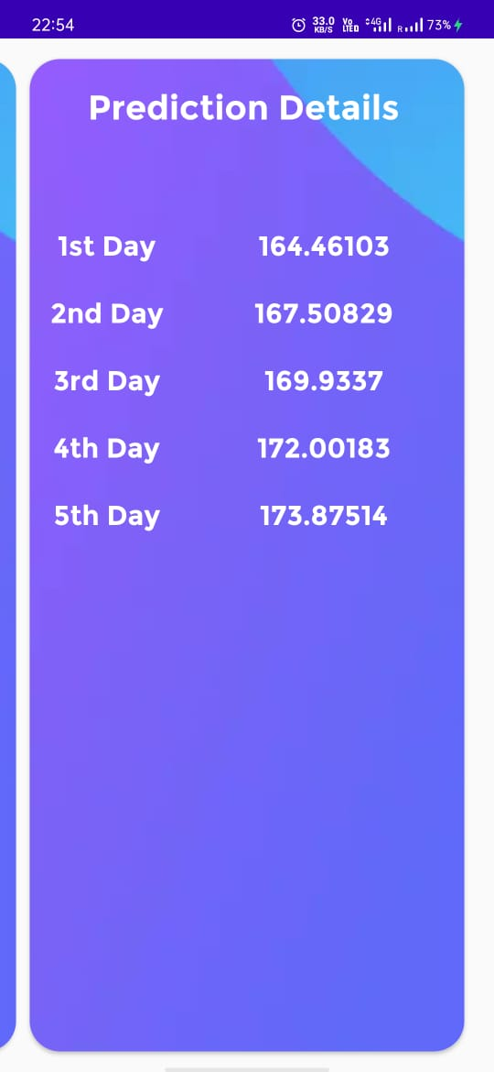

**STOCK MONEY LOGO:**



# Machine Learning Prediction Using Keras model

**1.Introduction of Machine Learning**

Machine learning is a subfield of artificial intelligence (AI). The goal of machine learning generally is to understand the structure of data and fit that data into models that can be understood and utilized by people.

Although machine learning is a field within computer science, it differs from traditional computational approaches. In traditional computing, algorithms are sets of explicitly programmed instructions used by computers to calculate or problem solve. Machine learning algorithms instead allow for computers to train on data inputs and use statistical analysis in order to output values that fall within a specific range. Because of this, machine learning facilitates computers in building models from sample data in order to automate decision-making processes based on data inputs.

Any technology user today has benefitted from machine learning. Facial recognition technology allows social media platforms to help users tag and share photos of friends. Optical character recognition (OCR) technology converts images of text into movable type. Recommendation engines, powered by machine learning, suggest what movies or television shows to watch next based on user preferences. Self-driving cars that rely on machine learning to navigate may soon be available to consumers.

Machine learning is a continuously developing field. Because of this, there are some considerations to keep in mind as you work with machine learning methodologies, or analyze the impact of machine learning processes.

## Machine Learning Methods

In machine learning, tasks are generally classified into broad categories. These categories are based on how learning is received or how feedback on the learning is given to the system developed.

Two of the most widely adopted machine learning methods are **supervised learning** which trains algorithms based on example input and output data that is labeled by humans, and **unsupervised learning** which provides the algorithm with no labeled data in order to allow it to find structure within its input data.

### Supervised Learning

In supervised learning, the computer is provided with example inputs that are labeled with their desired outputs. The purpose of this method is for the algorithm to be able to “learn” by comparing its actual output with the “taught” outputs to find errors, and modify the model accordingly. Supervised learning therefore uses patterns to predict label values on additional unlabeled data.

### Unsupervised Learning

In unsupervised learning, data is unlabeled, so the learning algorithm is left to find commonalities among its input data. As unlabeled data are more abundant than labeled data, machine learning methods that facilitate unsupervised learning are particularly valuable.

The goal of unsupervised learning may be as straightforward as discovering hidden patterns within a dataset, but it may also have a goal of feature learning, which allows the computational machine to automatically discover the representations that are needed to classify raw data.

**2.PREDICTION USING KERAS MODEL**

Keras is based on minimal structure that provides a clean and easy way to create deep learning models based on TensorFlow or Theano. Keras is designed to quickly define deep learning models. Well, Keras is an optimal choice for deep learning applications.

## Features

Keras leverages various optimization techniques to make high level neural network API easier and more performant. It supports the following features −

* Consistent, simple and extensible API.
* Minimal structure - easy to achieve the result without any frills.
* It supports multiple platforms and backends.
* It is user friendly framework which runs on both CPU and GPU.
* Highly scalability of computation.

## Benefits

Keras is highly powerful and dynamic framework and comes up with the following advantages −

* Larger community support.
* Easy to test.
* Keras neural networks are written in Python which makes things simpler.
* Keras supports both convolution and recurrent networks.
* Deep learning models are discrete components, so that, you can combine into many ways.

**APPLICATION PROGRAMMING INTERFACE(API)**

API is an abbreviation for Application Programming Interface which is a collection of communication protocols and subroutines used by various programs to communicate between them. A programmer can make use of various API tools to make its program easier and simpler. Also, an API facilitates the programmers with an efficient way to develop their software programs.  
Thus in simpler terms, an API helps two programs or applications to communicate with each other by providing them with necessary tools and functions. It takes the request from the user and sends it to the service provider and then again sends the result generated from the service provider to the desired user.

A developer extensively uses API’s in his software to implement various features by using an API call without writing the complex codes for the same. We can create an API for an operating system, database systems, hardware system, for a JavaScript file or similar object-oriented files. Also, an API is similar to a GUI (Graphical User Interface) with one major difference. Unlike GUI’s, an API helps the software developers to access the web tools while a GUI helps to make a program easier to understand by the users.

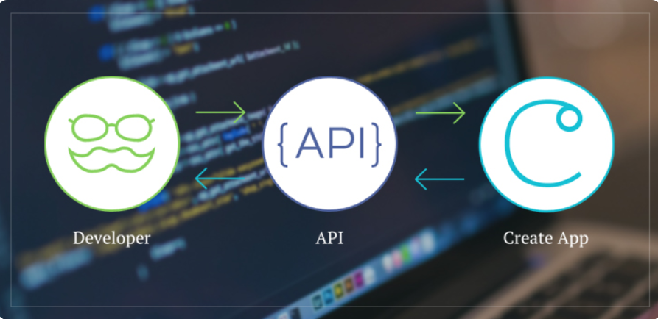

**WIREFRAMING**

Wireframing is one of the methods used in geometric modelling systems. A wireframe model represents the shape of a solid object with its characteristic lines and points. There are two types of wireframe modelling: Pro's and Con's. Pro's user gives a simple input to create a shape. It is useful in developing systems. While in Con's wireframe model, it does not include information about inside and outside boundary surfaces. Today, wireframe models are used to define complex solid objects. The designer makes a wireframe model of a solid object, and then the CAD operator reconstructs the object, including detailed analysis. This technique has some advantages: generally the 3-dimensional solid objects are complex, but wireframe models can be viewed in 1 dimension, improving comprehensibility; the solid object can be modified further; the designer can ignore the geometry inside a surface while in solid modelling the designer has to give consistent geometry for all details; wireframe models require less memory space and CPU capacity.

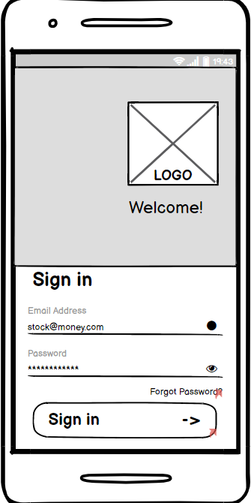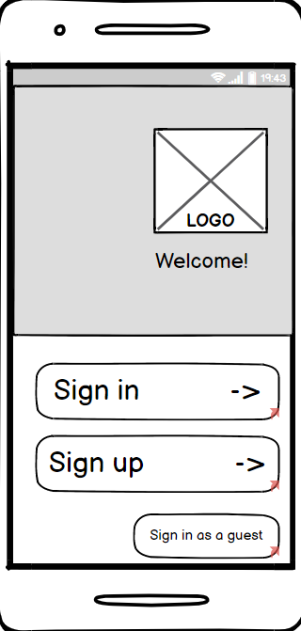

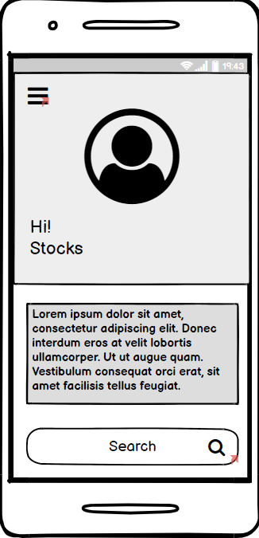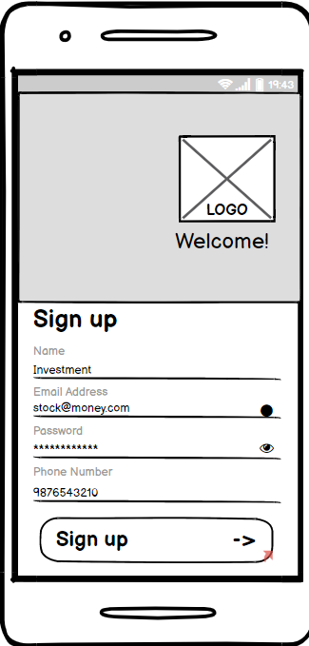

**LUCIDCHART**

**Lucid chart** is a web-based proprietary platform that allows users to collaborate on drawing, revising and sharing charts and diagrams. It is produced by Lucid Software.

The Basic UML Class Diagram for stock market prediction using lucid chart is given below:

**UML DIAGRAM:**

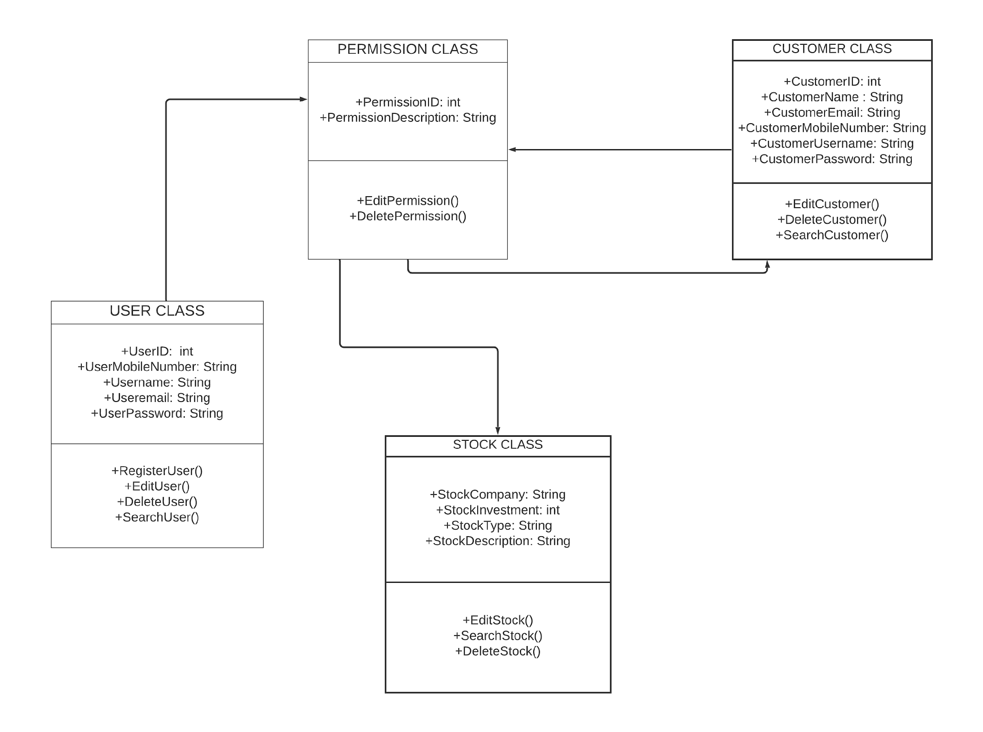

**ACTIVITY DIAGRAM:**

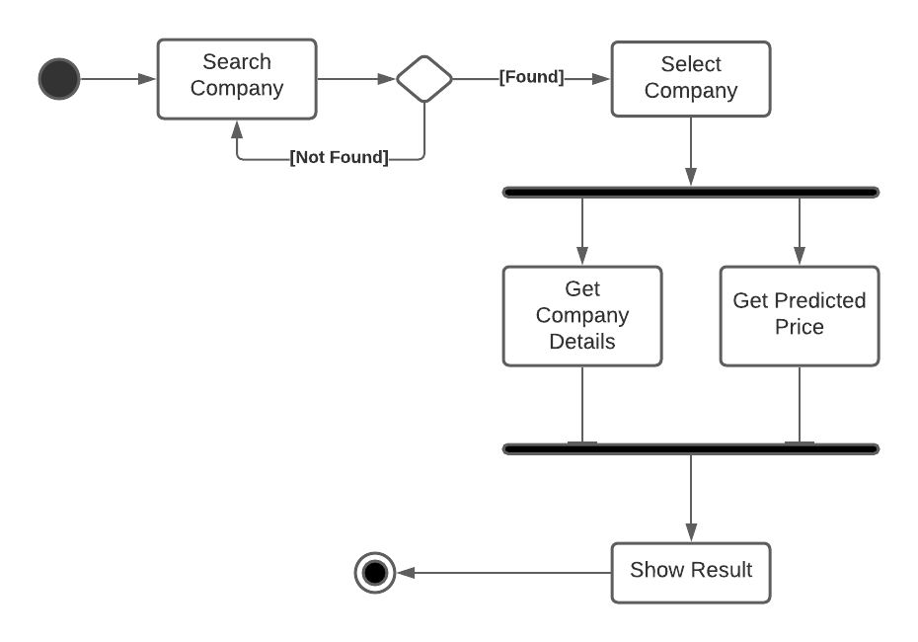

**USE CASE DIAGRAM:**

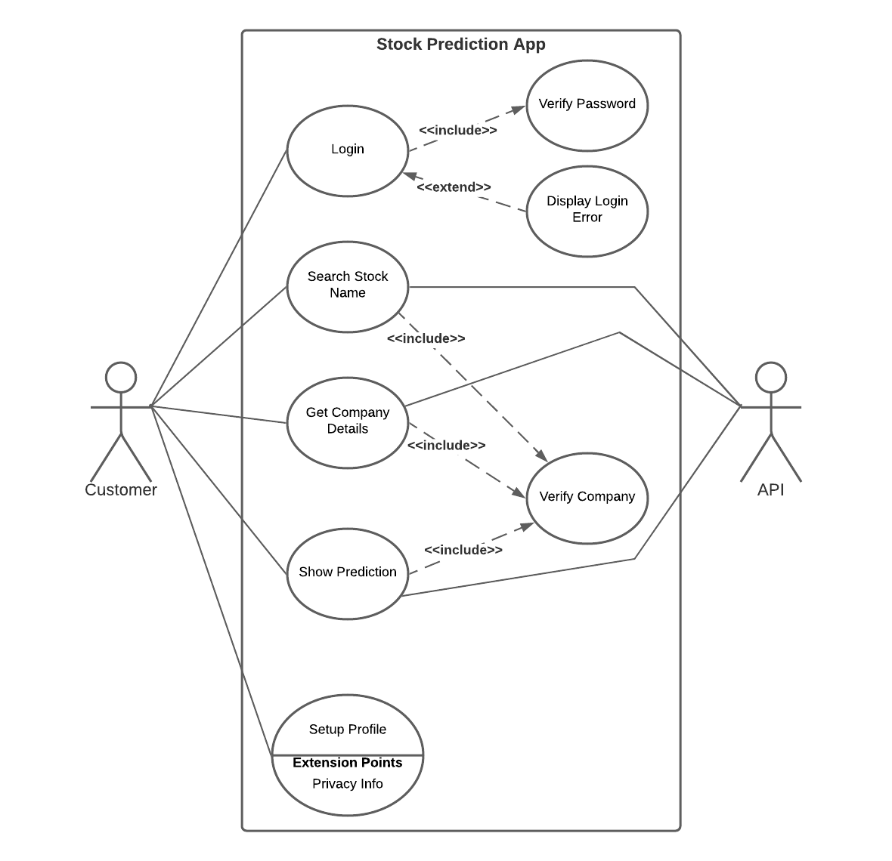

**ERD DIAGRAM:**

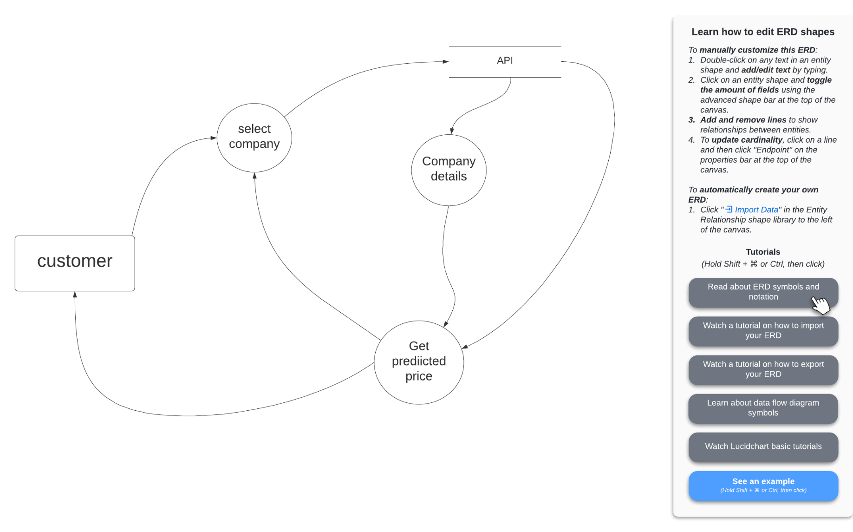

**BALSMIQ**

Balsamiq Wireframes is a **user interface design tool** for creating wireframes (sometimes called mockups or low-fidelity prototypes).

You can use it to generate digital sketches of your idea or concept for an application or website, to facilitate discussion and understanding before any code is written. The completed wireframes can be used for user testing, clarifying your vision, getting feedback from stakeholders, or getting approval to start development.

**FIREBASE**

Google Firebase is Google-backed application development software which allows developers to develop **Android, IOS,** and **Web apps**. For reporting and fixing app crashes, tracking analytics, creating marketing and product experiments, firebase provides several tools.

Firebase has three main services, i.e., a real-time database, user authentication, and hosting. We can use these services with the help of the Firebase iOS SDK to create apps without writing any server code.

**THE LANGUAGE USED: KOTLIN**

Kotlin is a compiled, statically typed language, which might provide some initial hurdles for people who are used to the interpreted, dynamically typed Python. This document aims to explain a substantial portion of Kotlin's syntax and concepts in terms of how they compare to corresponding concepts in Python.

Kotlin can be compiled for several different platforms. In this document, we assume that the target platform is the Java virtual machine, which grants some extra capabilities - in particular, your code will be compiled to Java bytecode and will therefore be interoperable with the large ecosystem of Java libraries.

**FIGMA DESIGNING**

**Figma is a cloud-based design and prototyping tool for digital projects. It’s made so that users can collaborate on projects and work pretty much anywhere.**

While this tool looks a lot like other prototyping options, the key differentiator is the ability to work with teams on projects. To date, Figma is probably the best-suited option available.

**COMPANY’S DETAILS**

This application named “Stock money: A Stock Market Prediction App” gives the details of the company that it’s shares are up or down in the market. When user wants to search for a share of a particular company, user can easily see it without any interpretation. On the front, user will see the company details and on the other side, user can the share value price of the company.

**Example**

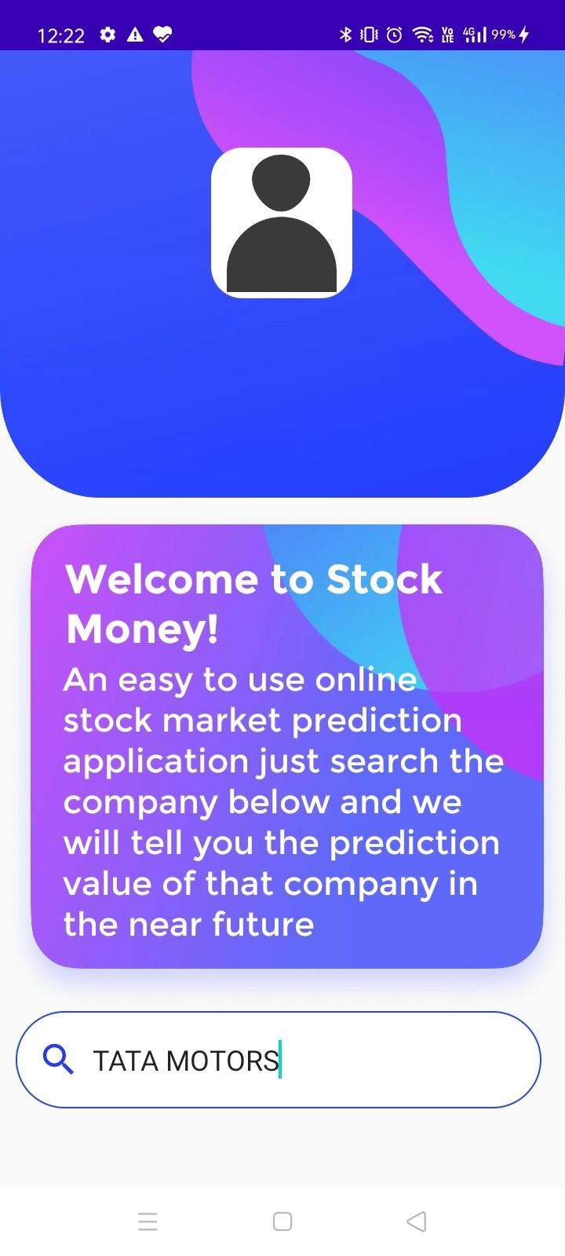

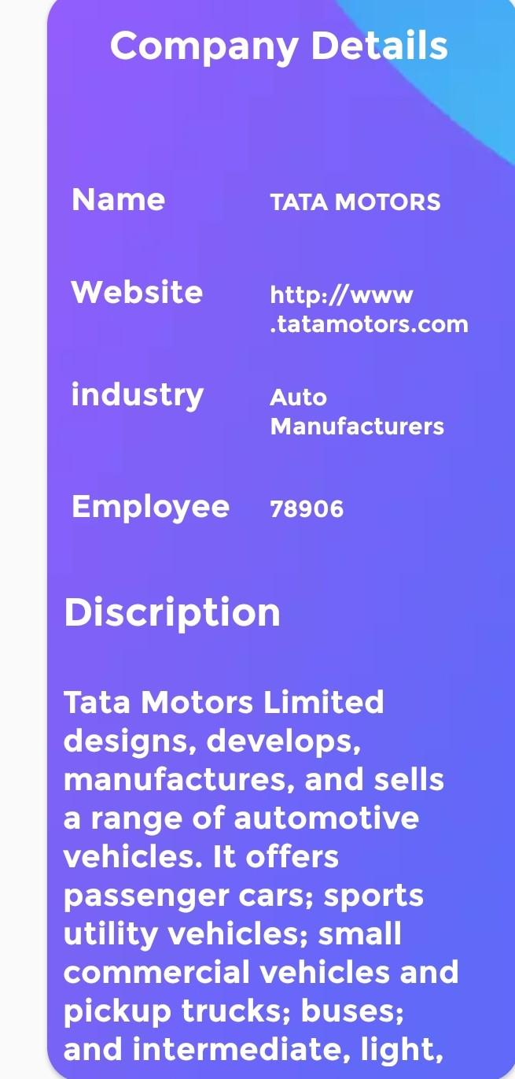 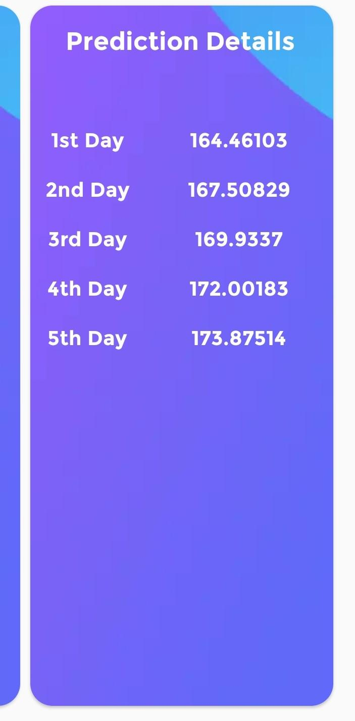

**REFERENCE :**

• [www.wikipedia.org/](http://www.wikipedia.org/%E2%80%A2)

[•](http://www.wikipedia.org/%E2%80%A2)[www.udemy.com/](http://www.udemy.com/)

• [www.google.com/](http://www.google.com/)